**How your   
Support Coordinators   
help you**

* We support you in meetings with the NDIS



* We help you get the NDIS funding you need
* We work with you (and your loved ones) to use your funding, to suit **your** needs and likes.



* We help you find ways around hurdles so that you can live life your way
* We show you how to use the NDIS online Portal, if you wish



* We report back to NDIS for you
* We connect you with therapists, services, supports and activities within your community

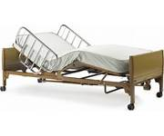

* We help if you need disability equipment e.g. adaptive shoes, iPad, bed, wheelchair, walker, cutlery … and many other things

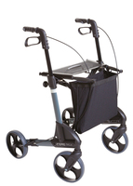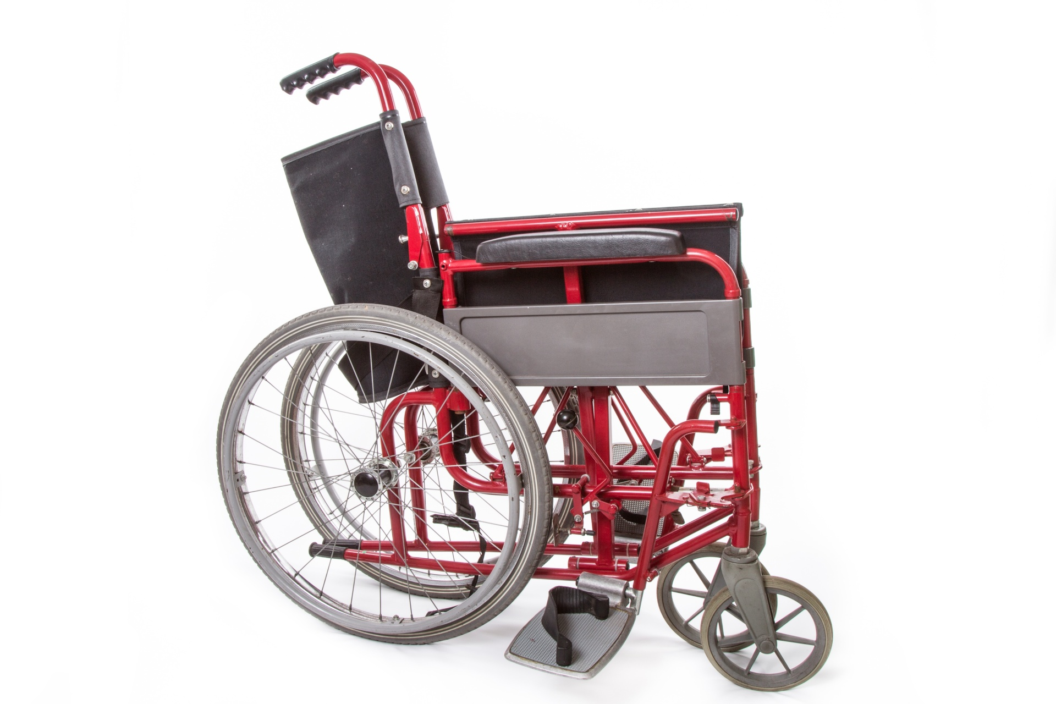

* We help with planning for home and housing

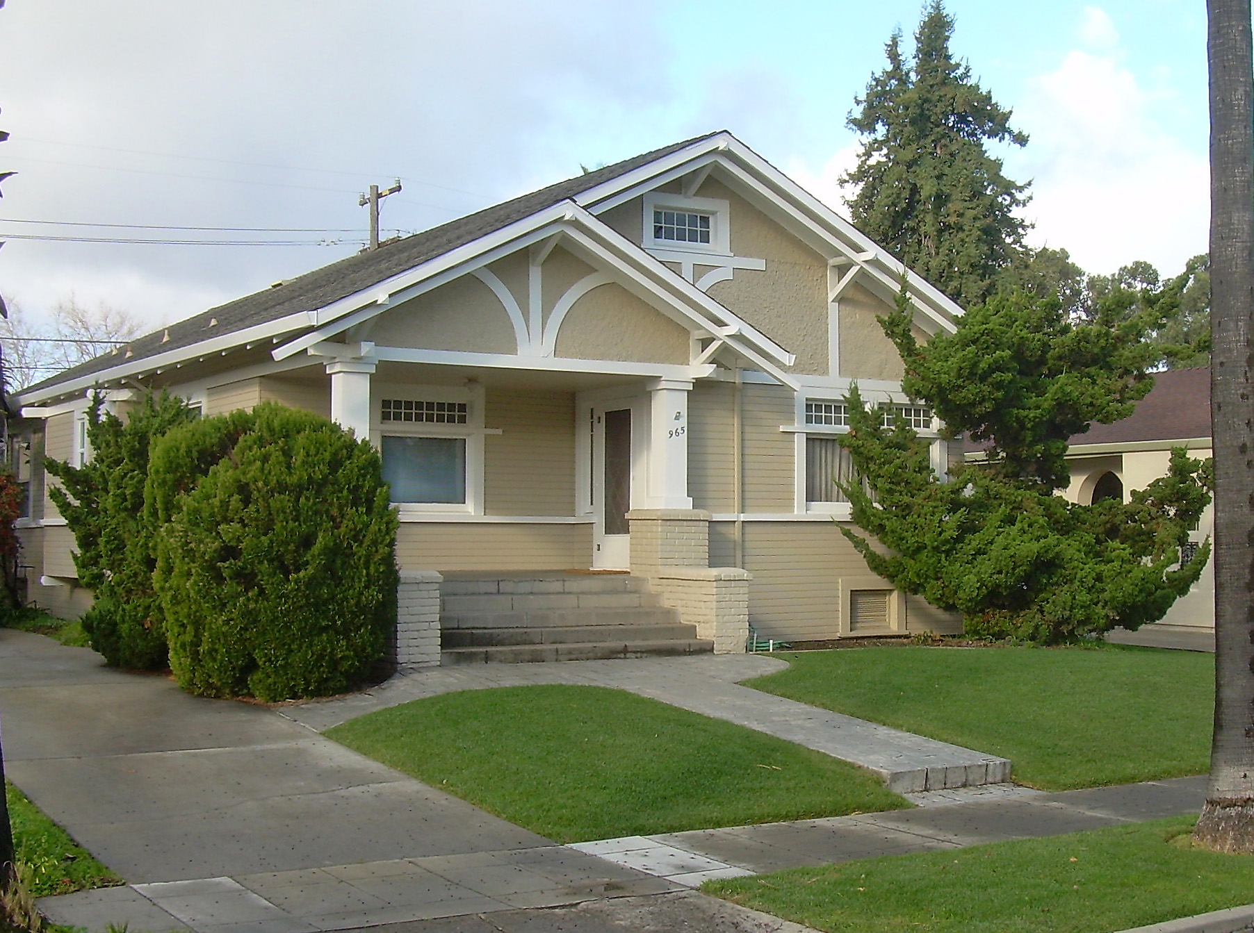

* We can link you to mainstream services too, such as doctor, advocacy, family services and housing.

**Support Coordination – Kyeema Support Services Inc**

Shop 7 Pioneer Plaza 103-111 Percy Street Portland Vic 3305

T: 03 5521 1666 M: 0448 992 354 E: SupportCoordination@kyeema.com.au

*Your Support Coordinator is: ­*